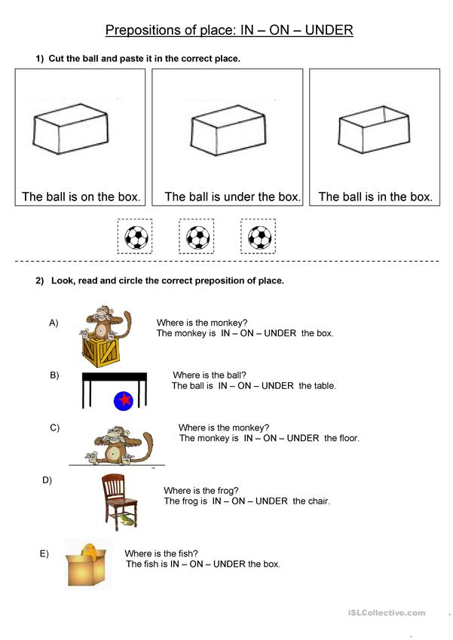
Name: ……………………………………………… Class: ……………………. Date: ……………………………………………….

