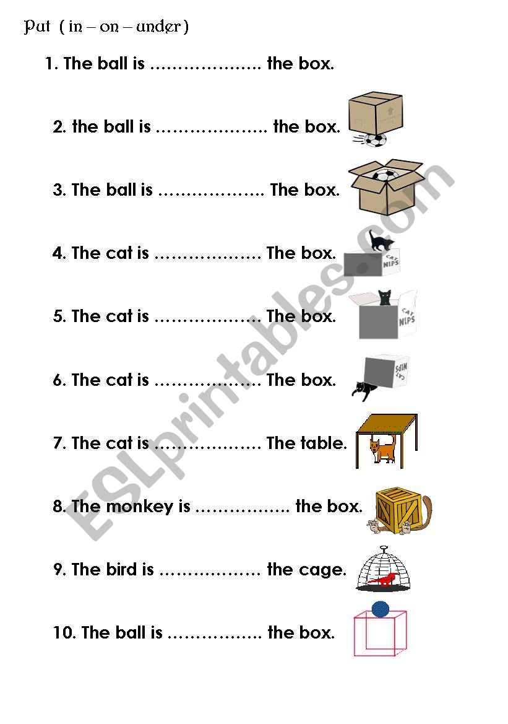
Name: ………………………………………………….. Class: ………………………. Date: …………………………………………

